Good Shepherd School Map
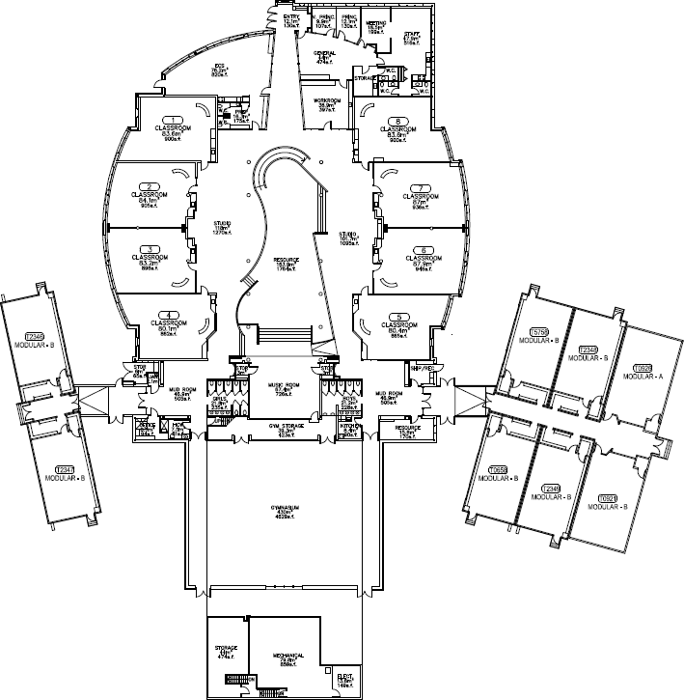


KC/KD
2B 2C
4D Gr. 5
2B 2C
4D
1D
4D
1A
1B
1C
1D
2A

3B3C4A4B
KA/KB/KC/KD
6B
1A
2C
3A 4C
2B, 2C, 4D will only use this entry/exit upon arrival and at dismissal.

Gr. 6
3B
5A
6C
3C
4A
6A
5C
5B
2B
1C
2A
1B
KA/KB
3A
4C
4B

